38983494
CMPG311 – Databases Assignment 1
- What is a relationship, and what three types of relationships exists?
-A relationship describes an association between entities and how they interact with one another. For example, if we have a PAINTING entity and an ARTIST entity, then the relationship between them will most likely be that one ARTIST paints many PAINTINGS which indicates a One-to-many relationship.

-The three types of relationships that exists are:
-One-to-many relationships
-One-to-one relationships
-Many-to-many relationships
2. Business rules for the given ERD
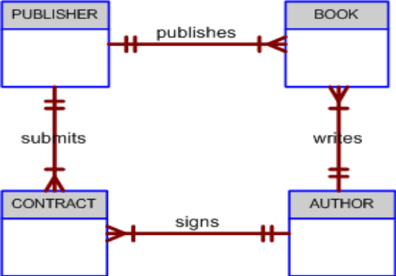
-Each author can sign many contracts but must at least be able to sign one contract
-Each author can write many books but must at least be able to write one book
-Each publisher can submit many contracts but must at least be able to submit one contract
-Each publisher can publish many books but must at least be able to publish one book

3. Most appropriate database design sequence of activities for the given steps
7___ Load the database.
8___ Create the application programs.
10__ Create a description of each system process.
5___ Normalize the conceptual model.
9___ Test the system.
1___ Obtain a general description of the soccer club operations.
4___ Create a conceptual model using ER diagrams.
3___ Interview the soccer club director of coaching.
2___ Interview the soccer club president.
6___ Create the file (table) structures.

